Laboratory 1: Signals and Noise

ECSE308 - Introduction to Communication Systems and Networks

Group C9

Ismail Faruk (260663521) and Marine Huynh (260743073)

*Abstract - The purpose of this 2-part lab is to understand the effect of different types of inputs on a system. The topics of noise, cut-off frequency and bandwidth will be explored. With the use of a software called Simulink, we will be able to analyze in greater depth the use of signals.*

INTRODUCTION

Laboratory 1 was given to have a better understanding on the basics of signals. We were able to generate input signal and observe the outcome. We used a software from MatLab called Simulink who would permit us to simulate and design embedded systems. Using blocks as components to implement and view how signals react from these parameters. This lab is a two-part lab where we have to firstly, understand the input signal on a time-domain and on a frequency domain. Also, we looked at the impact of noise. Then, we observed different properties such as the power, the bandwidth depending on the frequency and the signal-to-noise ratio (SNR), which once again was related to the noise. In the end, we were able to have a signal that has been under the effect of noise, but still be able to retrieve an approximation of the initial input signal.

First of all, in **Part 1**, we used Simulink to be able to observe the input/output signals. The blocks were connected as in *Figure 1* to view the data on the scope and the spectrum graphs. We then observed some basic characteristic of waves such as the amplitude, the period, the fundamental and harmonic frequencies. The 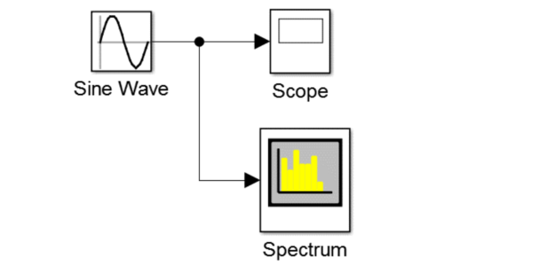*Figure 1: System of an input sinusoidal signal.*

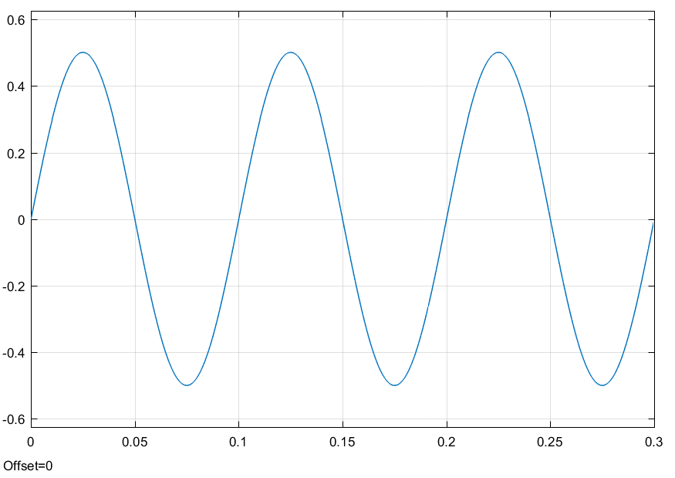inputs were generated from different functions: a sinusoidal function, a triangle function and a pulse function. Each input signal was connected in the similar way as *Figure 1*, by replacing the type of source. For the sinusoidal wave, we have graphs of the scope and the spectrum over three periods. *Figure 2 and 3* display the outputs.

*Figure 2: Scope of a sine wave.*

*Figure 3: Spectrum of a sine wave.*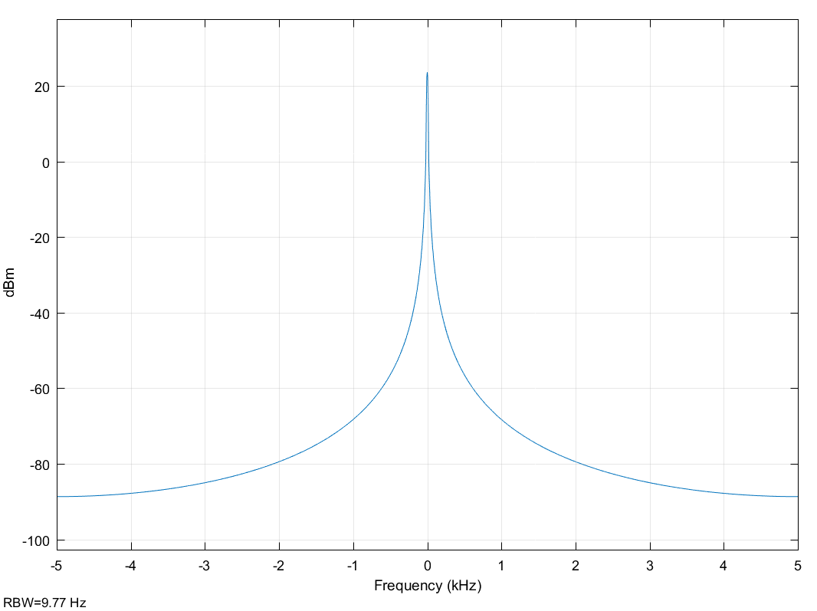

From these graphs as well as the parameters specified in the handout, we can find that the amplitude of the signal is 0.5, the period is 0.1s and the frequency is 10Hz. The frequency can be divided into two types: the fundamental and the harmonics. The fundamental frequency is the lower frequency produced. Whereas, the 2nd harmonic frequency is twice the value of the fundamental frequency and the 3rd harmonic is 3 times the fundamental frequency and on and so forth. Thus, in this *Figure 4: Scope of a triangular wave.* 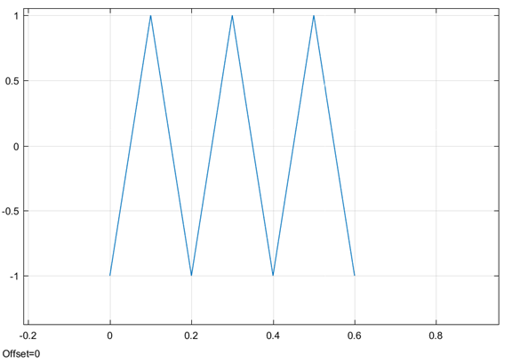

case of a wave of 3 period, the fundamental frequency is 10 Hz, the 2nd harmonic is 20Hz and the 3rd harmonic is 30Hz.

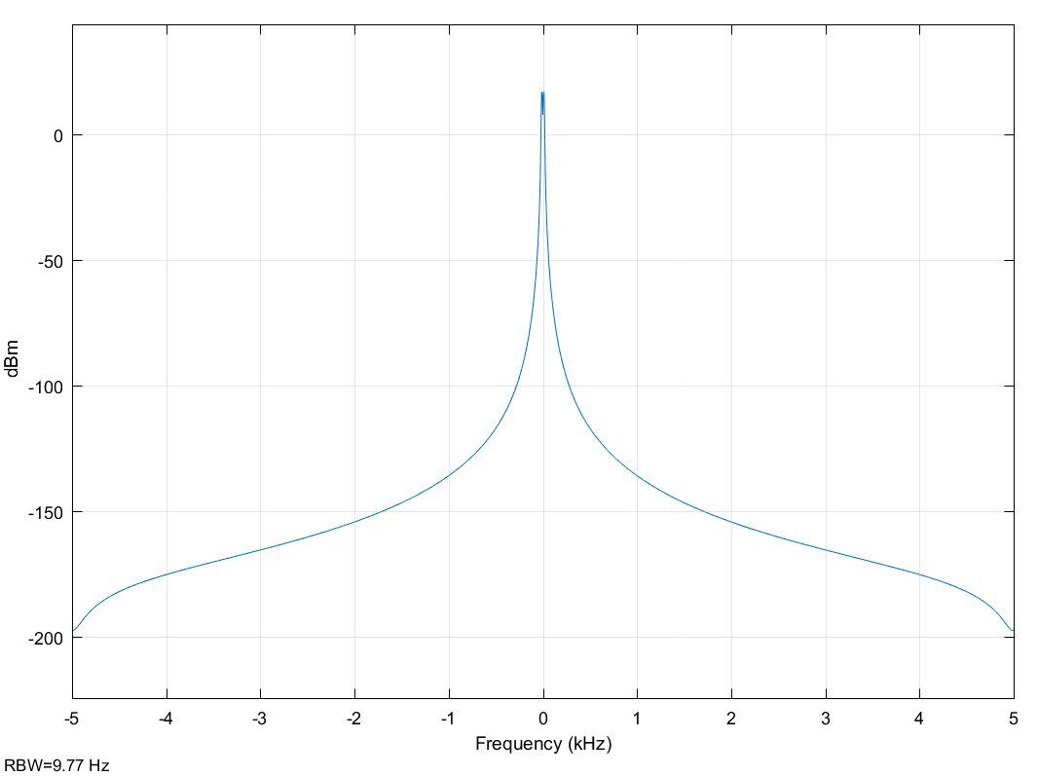For the triangle wave *Figure 4 and 5* of the scope and the spectrum respectively are shown below.

*Figure 5: Spectrum of a triangular wave.*

The amplitude of the triangular wave is 1, its period is 0.2s and the fundamental frequency is 5Hz. Thus, we can calculate the 2nd harmonic to be 10Hz and the 3rd harmonics to be 15Hz.

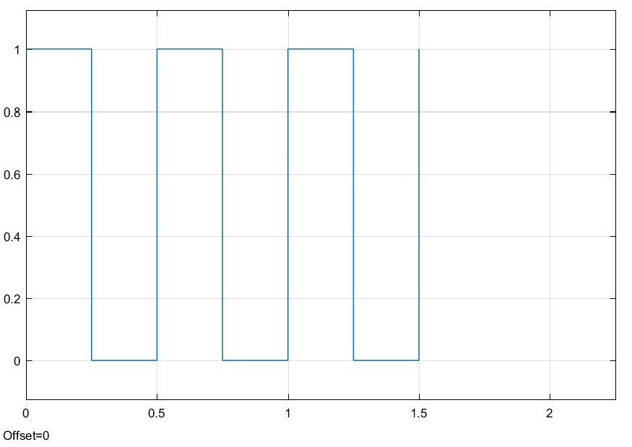We have the scope and the spectrum in *Figure 6 and 7* of a square wave with a 50% duty cycle.

*Figure 6: Scope of a 50% duty cycle square wave.*

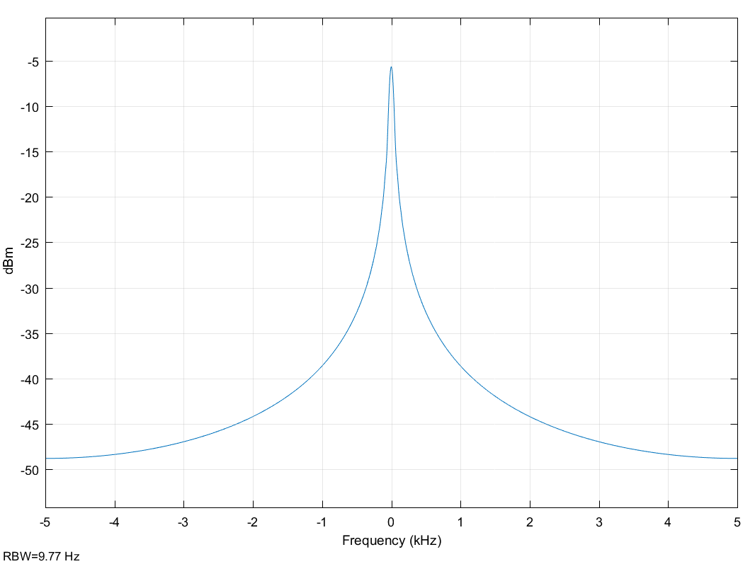*Figure 7: Spectrum of a 50% duty cycle square wave.*

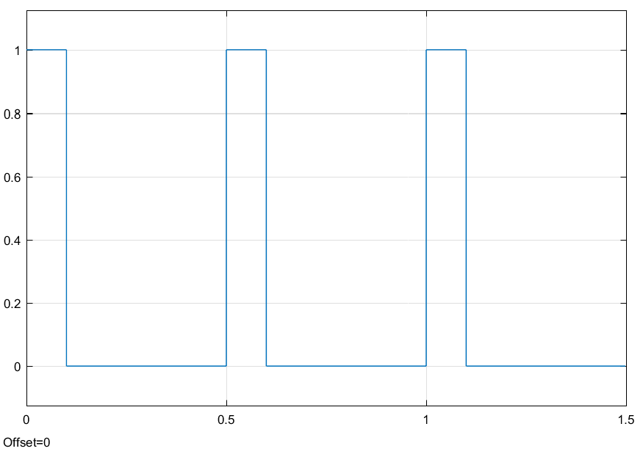Then, we have the scope and spectrum graphs for a 20% duty cycle are shown right after in *Figure 8 and 9*.

*Figure 8: Scope of a 20% duty cycle square wave.*

These square waves seen in Figure 6 and 8 both have an amplitude of 1 since they are pulse functions, where the value is either 0 or 1. The period is 0.5s and the frequency is 2Hz. Thus the 2nd harmonic is 4Hz and the 3rd harmonic is 6Hz. The difference between these two scopes is the percent of

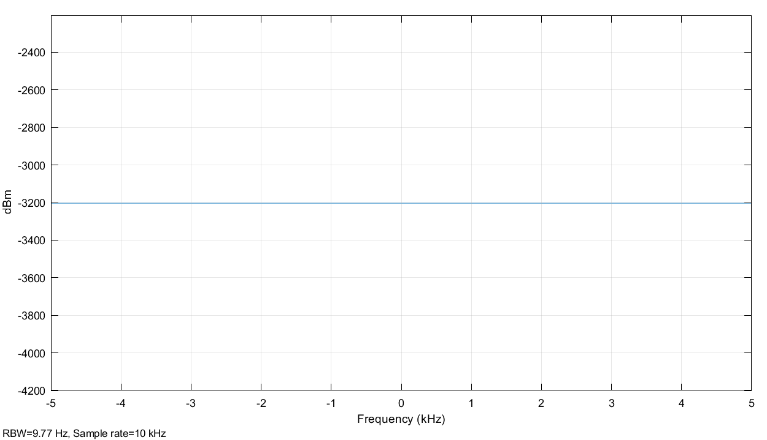*Figure 9: Spectrum of a 20% duty cycle square wave.*

duty cycle. This percentage is the ratio of steps of each period. It permits to have a greater visual as a pulse is only a point in time where it is high. By having a greater duty cycle, the pulse function becomes more and more like a square wave.

Another experiment was to sum up multiple sine waves with different values of amplitude and sample per period, which concludes with different frequencies. By summing these waves together, we obtain a new wave. This is shown in *Figure 10* over three periods.

We can observe from the graph in *Figure 10* that the amplitude of is lower than the sum of all the amplitudes of each sine wave. The actual value is 3.85. This is due to the fact that the frequencies of each individual wave is also different. Thus, their peak values do not occur at the same point in time. The period of the summed wave is 0.1s, which is the longest period from the three input waves. Due to the fact that all input waves have the same sample time, the period will depend on the number of samples per period. One of the waves has 1000 samples per period, and the others are

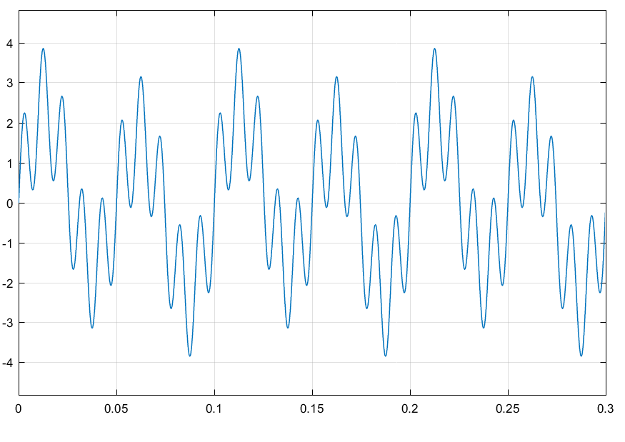*Figure 10: Scope of three sine waves added together.*

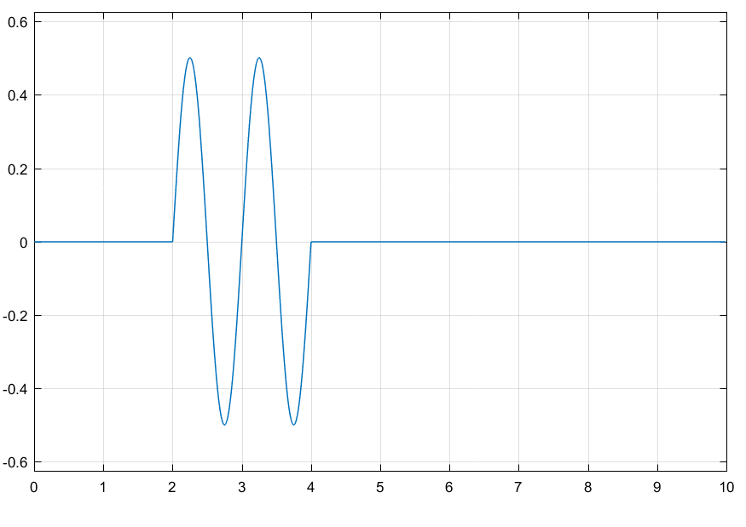less, then this higher value will take over to have enough samples to have all the data points for the generated waves. From a period of 0.1s then the frequency is 10Hz for the summed wave. The fundamental frequency is then 10Hz, the 2nd harmonic is 20Hz and the third harmonic is 30Hz for a sine wave over three periods.

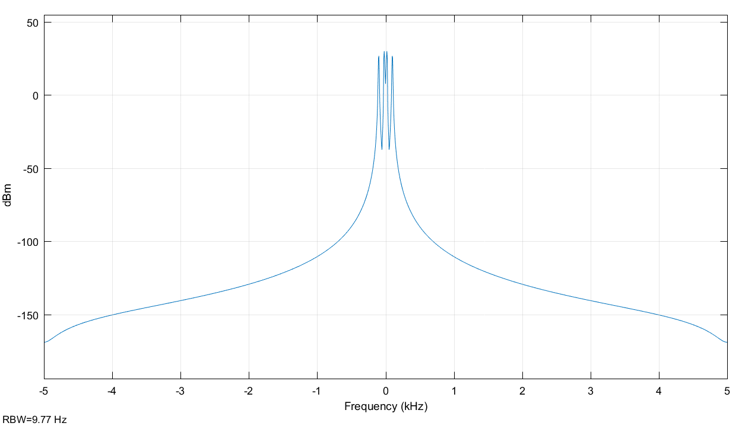The spectrum of the summed waves can be seen below in *Figure 11*.

*Figure 11: Spectrum of three sine waves added together.*

For the next experiment case, we constructed a system using Simulink as in *Figure 12*.

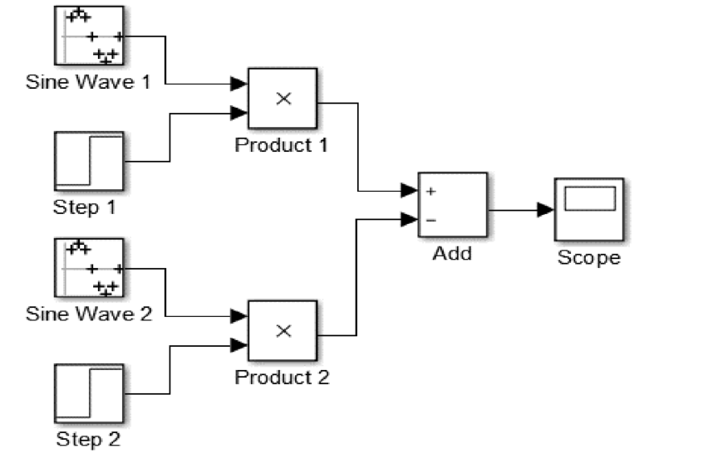

*Figure 12*: *System of two sinusoidal signal acting as step functions.*

By generating these waves, we can compile the software so that the scope is displayed as shown in *Figure 13.*

*Figure 13: Output scope of two step functions added together.*

From *Figure 13*, we can observe that the amplitude is 0.5, which is the amplitude of the individual input signals. Compared to the previous experiment of the three summed waves, the number of samples per period and the sample time for each input wave is equal. Therefore, the period and the frequency of the summed output wave will be the same. The period of the output signal is 1s and its fundamental frequency is 1Hz. However, the period is not continuous in time. This is due to the step functions related to each sine wave. One has a time step of 2, 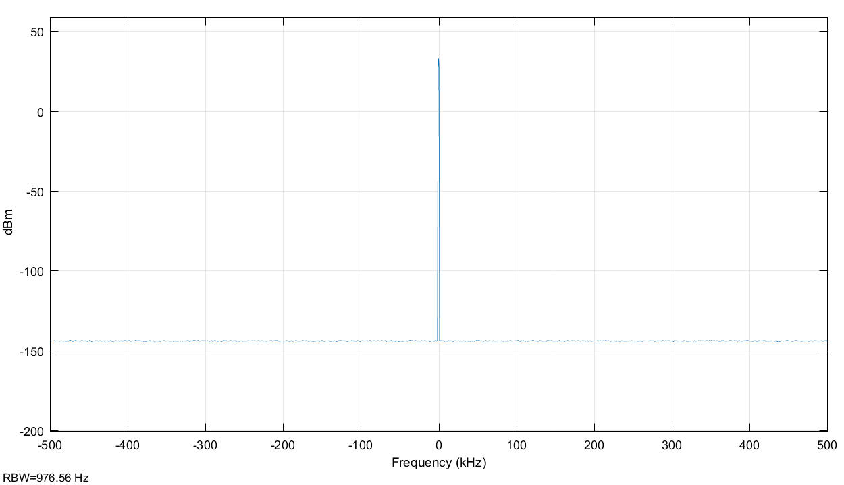and the other of 4. A step function is a function that is high when its value is 1, and is called low, when its value is 0. Thus, starting from time 0, none of the wave signals are on, since their step time is further. Arriving at time 2, the first input wave is high and thus displayed. This is the wave we can see in *Figure 13*. This wave can be seen until time 4 because at time 4, the second input wave is high. Then the waves are cancelling each other out since they have the same amplitude, frequencies and phase shift. The output scope shows then a constant value of 0 after time 4. We can then express the output signal as the following:

For 0<t<2

y(t) = 0

For 2≤t≤4

y(t) = 0.5*sin(2*π*1Hz * t)

For 4>t

y(t) = 0

Therefore, for 2≤t≤4, the period is 1, as the signal is non-zero only from time 2 to 4.

Next part of the lab was to observe the impact of thermal noise. Thermal noise is also called the Johnson-Nyquist noise, which is the agitation of molecules inside the electric conductors due to temperature. Thus, depending on the ambient temperature, the amount of noise will fluctuate. In this experiment, we set a noise temperature of 290K.

By setting the noise to 290K in the system, we obtain a spectrum as shown in *Figure 14*.

*Figure 14: Spectrum of thermal noise signal.*

The bandwidth of the signal is seen as a pulse in on graph. The noise power spectral density (N0) can be calculated from the Boltzmann constant times the temperature in Kelvins. Knowing that the Boltzmann constant is approximately 1.3806×10-23 m2 kg s-2 K-1 and the temperature under which the system is 290K, then the power spectral density is equal to 4.00 x 10-21 W/Hz.

A noise power can be generated and observed in *Figure 15*. By varying the variance of the noise signal inputted, we can observe a direct correlation between the value of the variance and the peak of the autocorrelation graph. The value of the peak is equal to the variance, which indeed is equal to the noise power. Therefore in *Figure 15*, we can see that the noise power of the signal is 1W. Therefore, for a smaller variance, the noise power will be smaller too.

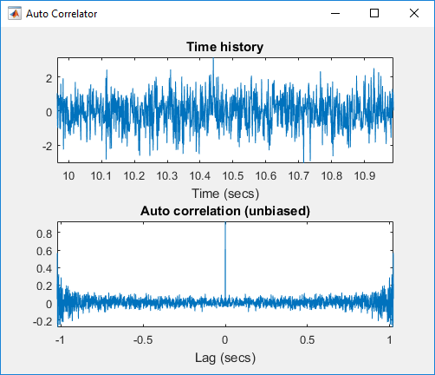*Figure 15: Noise Power for a signal with variance of 1.*

The thermal noise experiment introduced the use of a random source signal compared to the first experiment in *Figure 1* which used input signals called deterministic signals. Deterministic signals are when there is no uncertainty on a specific instant of time where the wave has a value. In other words, a deterministic signal can be expressed as a mathematical function with a precise period or a quasi-period. On the contrary, a random signal is when there is doubt in the value at some instance in time. Thus, in the example or reproducing noise, a random signal is much more appropriate as it does not have a specific pattern where we can know for a fact the value at a specific time t.

Next for **Part 2**, we continued with Simulink to be able to observe input/output signals. The blocks were connected as in *Figure 1* above to view the data on the scope and the spectrum graphs. We then observed the signal without, with and filtered noise. The inputs were generated from different functions: a sinusoidal function, a triangle function and a pulse function. An additional gain of 10 dB was added to the source.

We initially observed the spectrum and power with four sources. We started with a sine wave as a source. We observed the spectrum of the sine wave in *Figure 16*. Its measured power was 16.99 dB, with added 10 dB gain, and measured bandwidth was 214.76 Hz.

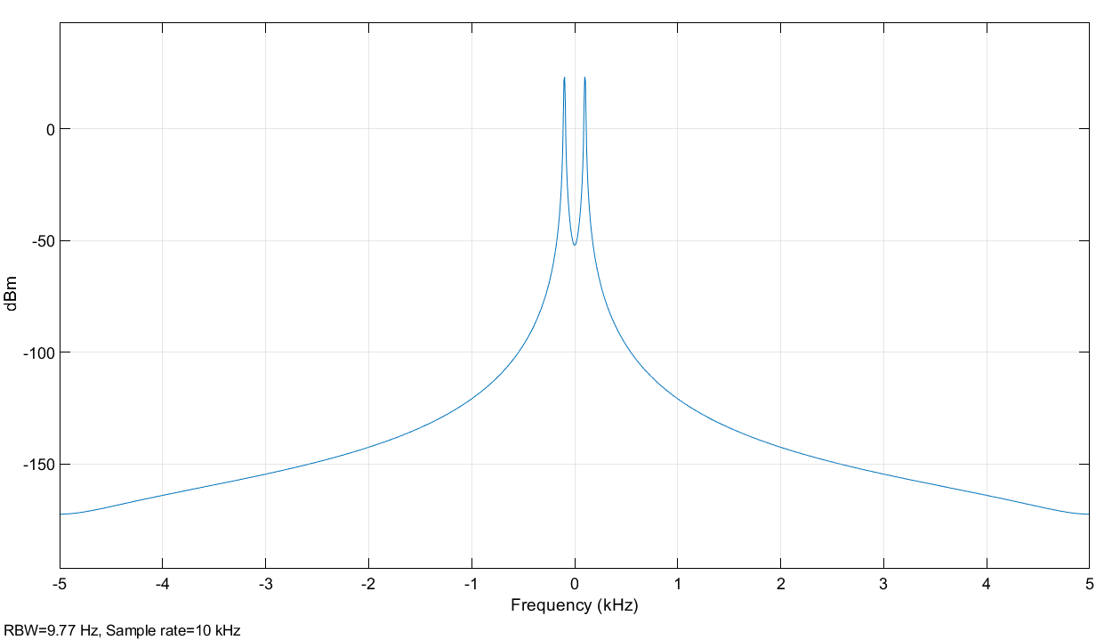

*Figure 16: Spectrum of sine wave*

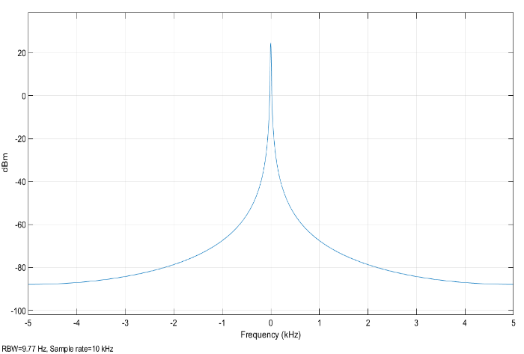We then used a triangular wave as source. We observed the spectrum of the triangular wave in *Figure 17*. Its measured power was 15.23 dB, with added 10 dB gain, and measured bandwidth was 31.9 Hz.

*Figure 17: Spectrum of triangular wave, with gain*

Next, we used a pulse wave with 50% duty cycle as a source. We observed its spectrum in *Figure 18*. Its measured power was 16.99 dB, with added 10 dB gain, and measured bandwidth was 1.98 kHz.

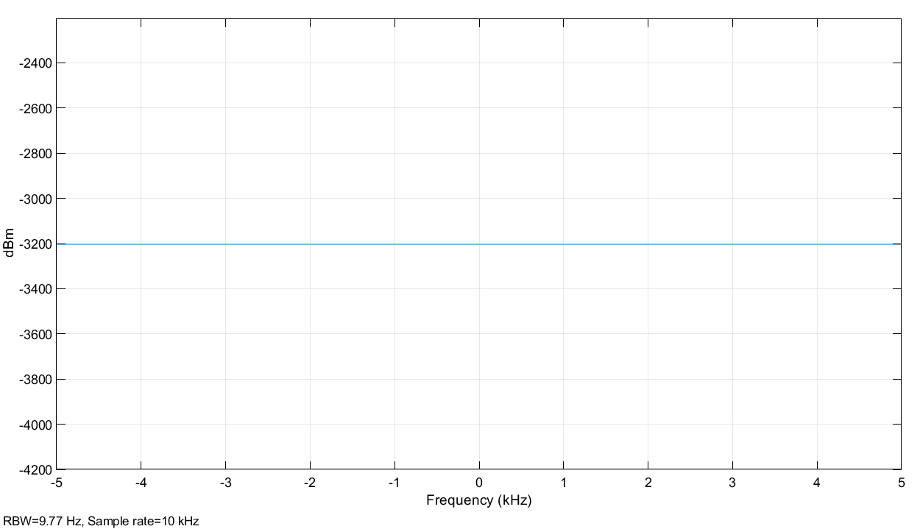

*Figure 18: Spectrum of pulse wave with 50% duty cycle*

Then, we used a pulse wave with 10% duty cycle as a source and *Figure 19* shows the spectrum of the source with the added gain. Its measured power was 13.01 dB, with added 10 dB gain, and measured bandwidth was 1.98 kHz.



*Figure 19: Spectrum of pulse wave with 10% duty cycle*

Finally, we used the sum of three sine waves as source and observed its spectrum, *Figure 20*. Its measured power was 25.12 dB, with added 10 dB gain, and measured bandwidth was 214.02 Hz.

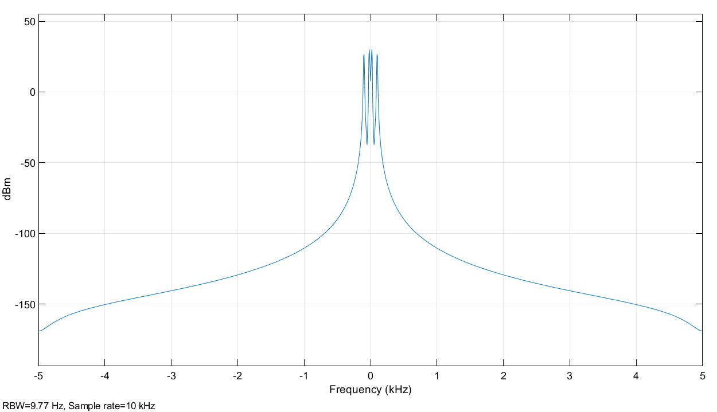

*Figure 20: Spectrum of sum of sine waves*

Then we observed the Scope Rx and Spectrum Rx of for the sum of sine waves, with added of noise.

We can observe from Scope Rx, *Figure 21*, that the wave is not smooth and has sharp edges. The amplitude of the wave is more that what it is theoretically expected, because of the noise.

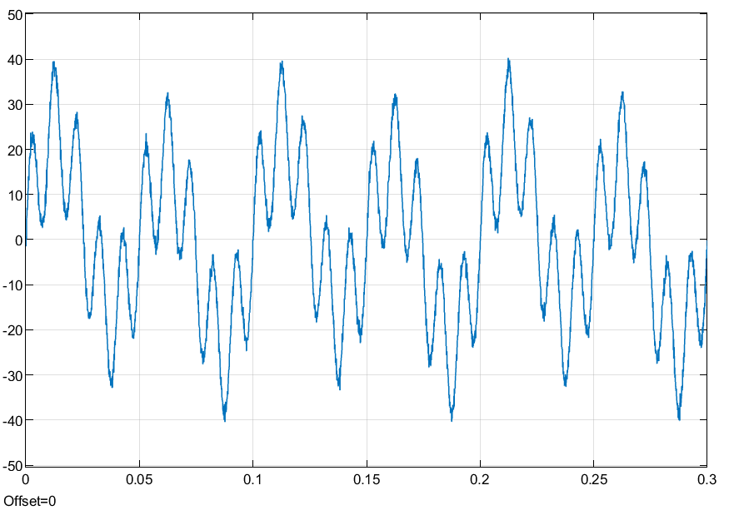

*Figure 21: Scope of Rx*

We can observe from Spectrum Rx that outside a certain bandwidth, the spectrum was distorted due to the noise. The shape of spectrum was distorted for lower values of power and are not identifiable at all, which were previously identifiable for the source without the added noise.

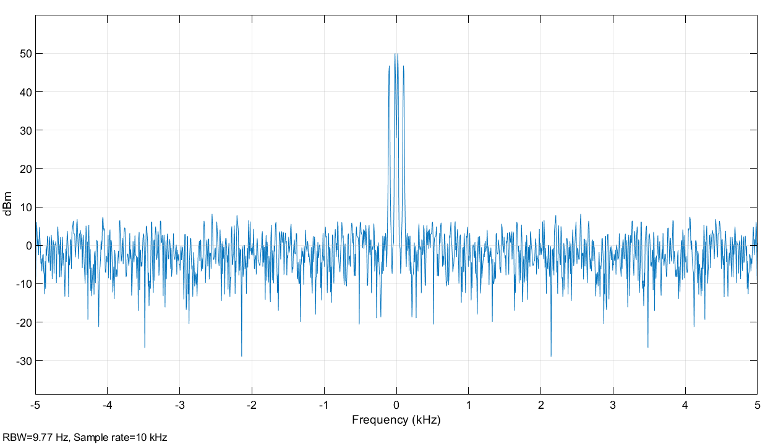

*Figure 22: Spectrum of Rx*

We then observed the scope filtered and spectrum filtered of the sum of sine waves with added noise and then filtered.

We can observe from the scope filtered in *Figure 23* that the filtered wave was smoother. The amplitude of the wave is now less than what it is theoretically expected, because of the noise was filtered out.

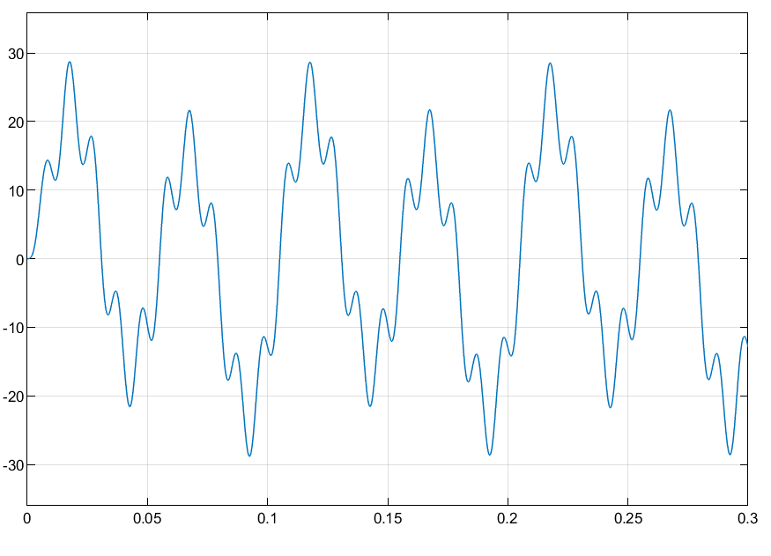

*Figure 23: Scope (Filtered)*

We can observe from the spectrum (filtered) in *Figure 24*, that the filtered spectrum has a shape similar to that without noise in *Figure 20*. The signal spectrum is now more distinguishable for the most part and is differentiable from the noise than that in *Figure 22*.

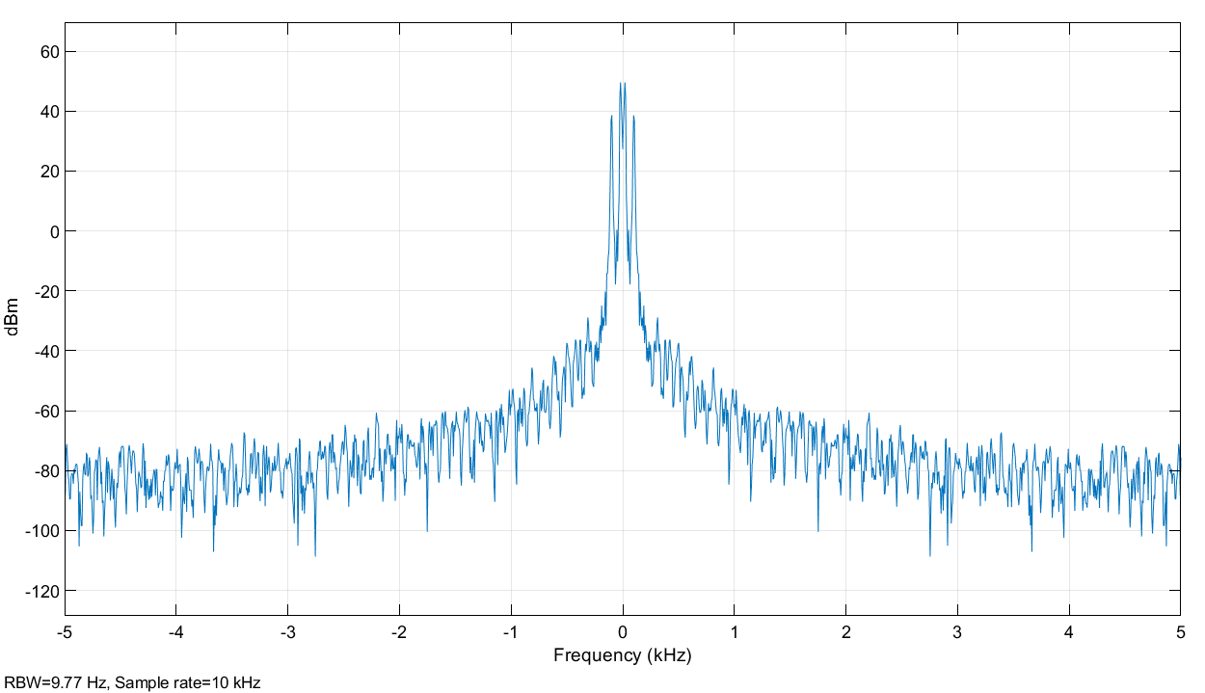

*Figure 24: Spectrum of Rx*

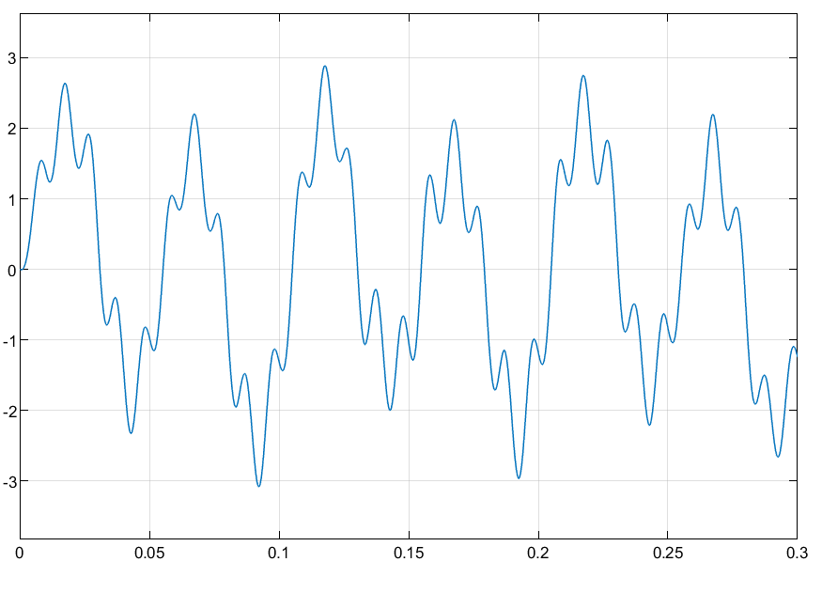

*Figure 25: Scope (filtered) with gain 1 db*

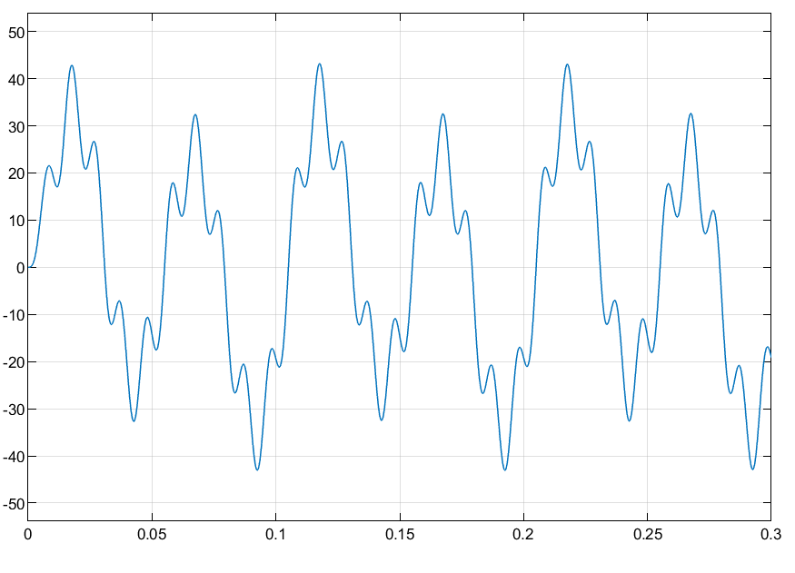

*Figure 25: Scope (filtered) with gain 15 db*

Changing the gain, we observe that the peak values for Scope (filtered) change according to the scope value, but it does not affect the general shape of the scope, which can be observed from *Figure 25* and *Figure 26*.

However, with a higher gain, observing the Spectrum (filtered), we can see that the signal bandwidth is more than that for a lower gain, observable in *Figure 27* and *Figure 28*.

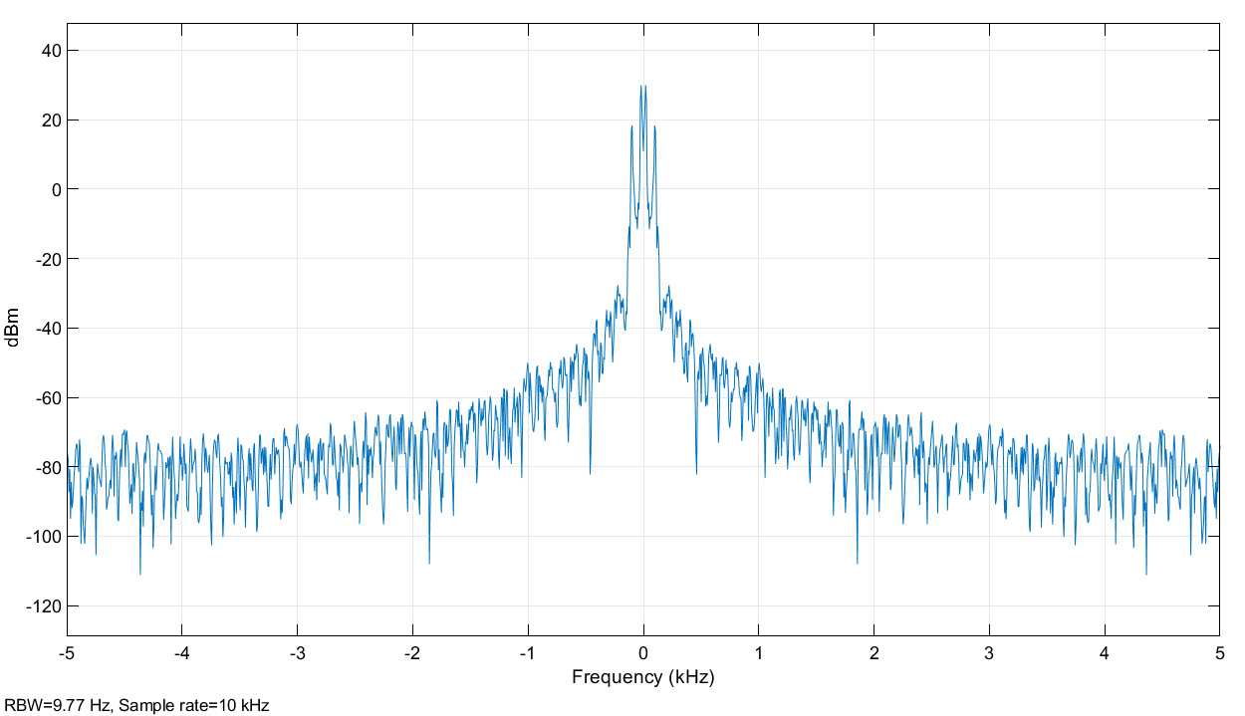

*Figure 27: Spectrum (filtered) with gain 1 db*

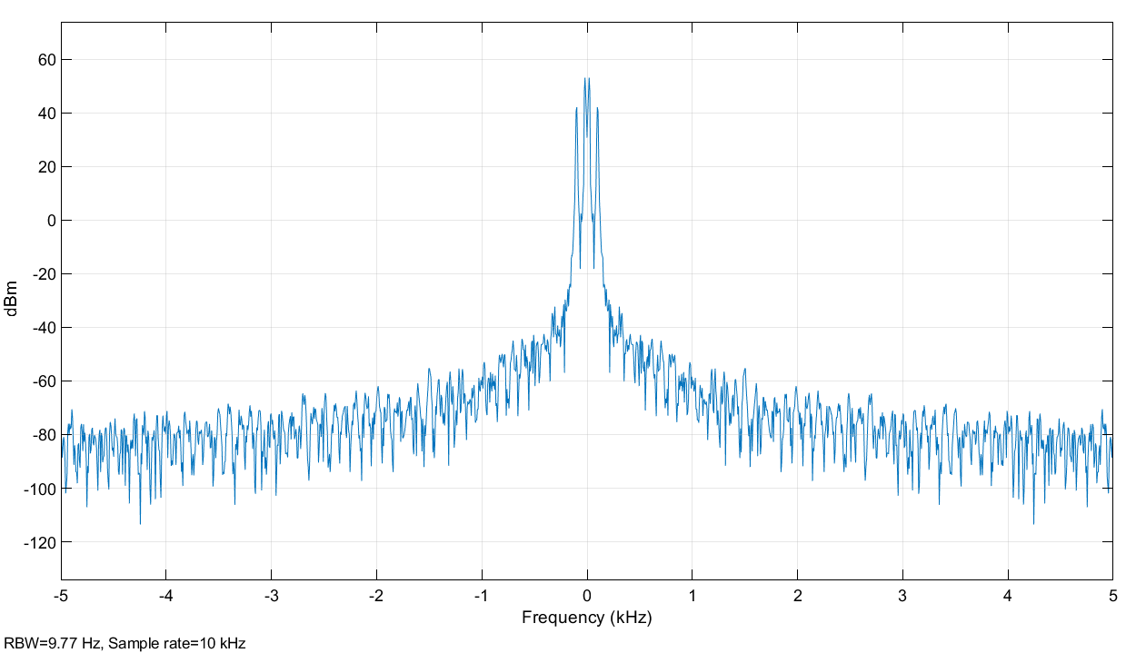

*Figure 28: Spectrum (filtered) with gain 15 db*

Changing the cutoff frequency, we observe that the general shape for Scope (filtered) is different and we have lower peak values for lower fc, *Figure 29*, than that for higher fc, *Figure 30*. That is because the signal started to be attenuated from a frequency much lower than before and the channel power dropped more.

We can observe in the spectrum that for a lower Fc we will be getting less bandwidth for the signal, reducing the noise, *Figure 31*, this could be a problem as we will be having a weak signal. In the spectrum with higher Fc, *Figure 31*, we can see that the bandwidth is larger and now incorporates more noise. This makes the signal more noisy.

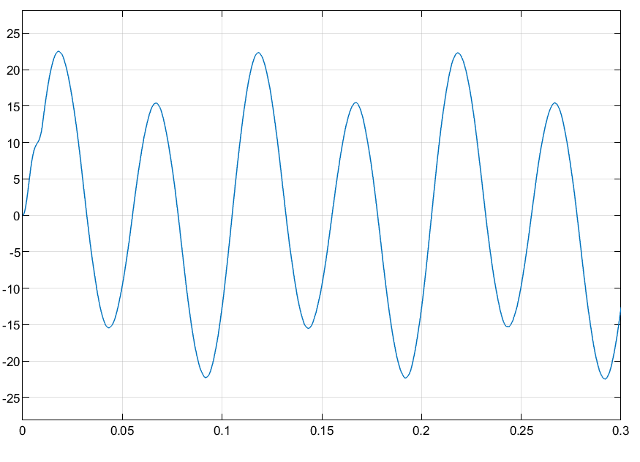

*Figure 29: Scope (filtered) with fc 10 Hz*

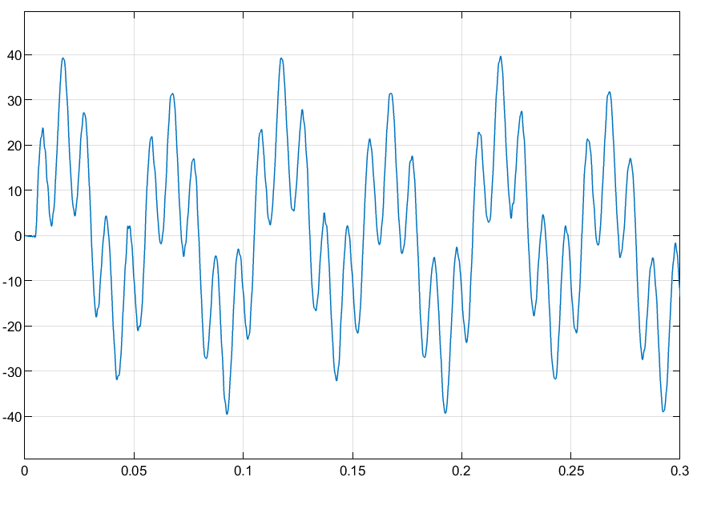

*Figure 30: Scope (filtered) with fc 1000 Hz*

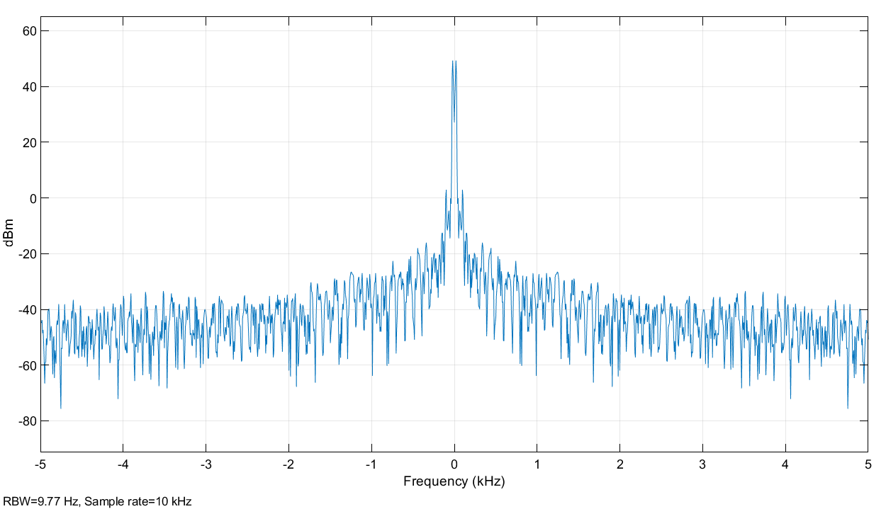

*Figure 31: Spectrum (filtered) with fc 10 Hz*

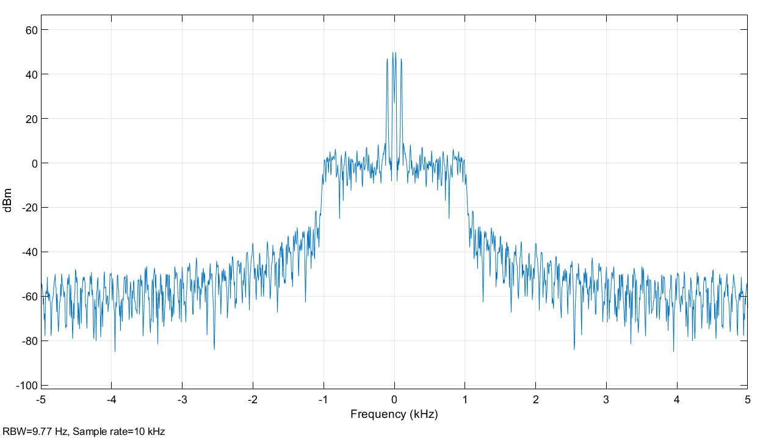

*Figure 32: Spectrum (filtered) with fc 1000 Hz*

Thus, for a higher gain, the filtered SNR is 47.61 and for a lower gain, the filtered SNR is 23.69. This is because as we increase the gain, we generate a signal with more amplitude, which can be more differentiable from the noise, than if we reduce the gain.

Also, for lower Fc, the filtered SNR was 44.66 and for higher Fc, the filtered SNR was 32.19. This is because, as we lower the Fc, we reduce the noise, increasing the SNR value.

Overall, we have a better understanding and a greater appreciation for systems with deterministic input signals and random signals. We saw the impact of noise such as thermal noise of a signal and looked at the use of filtering to be able to have back an approximation of an input signal.